# CS 255 System Design Document Template

## UML Diagrams

### UML Use Case Diagram

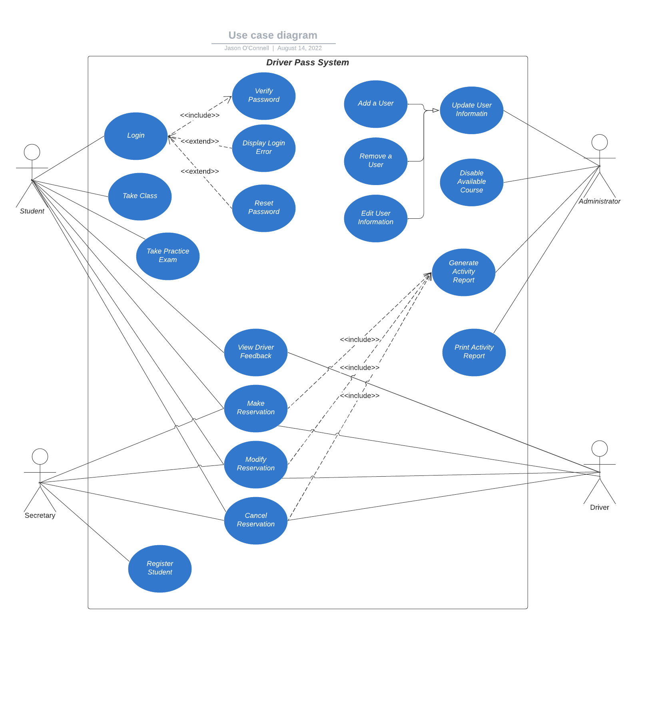

### UML Activity Diagrams

Activity Diagram for Making a Reservation

Activity Diagram for Resetting a Password

### UML Sequence Diagram

Sequence Diagram for Resetting a Password

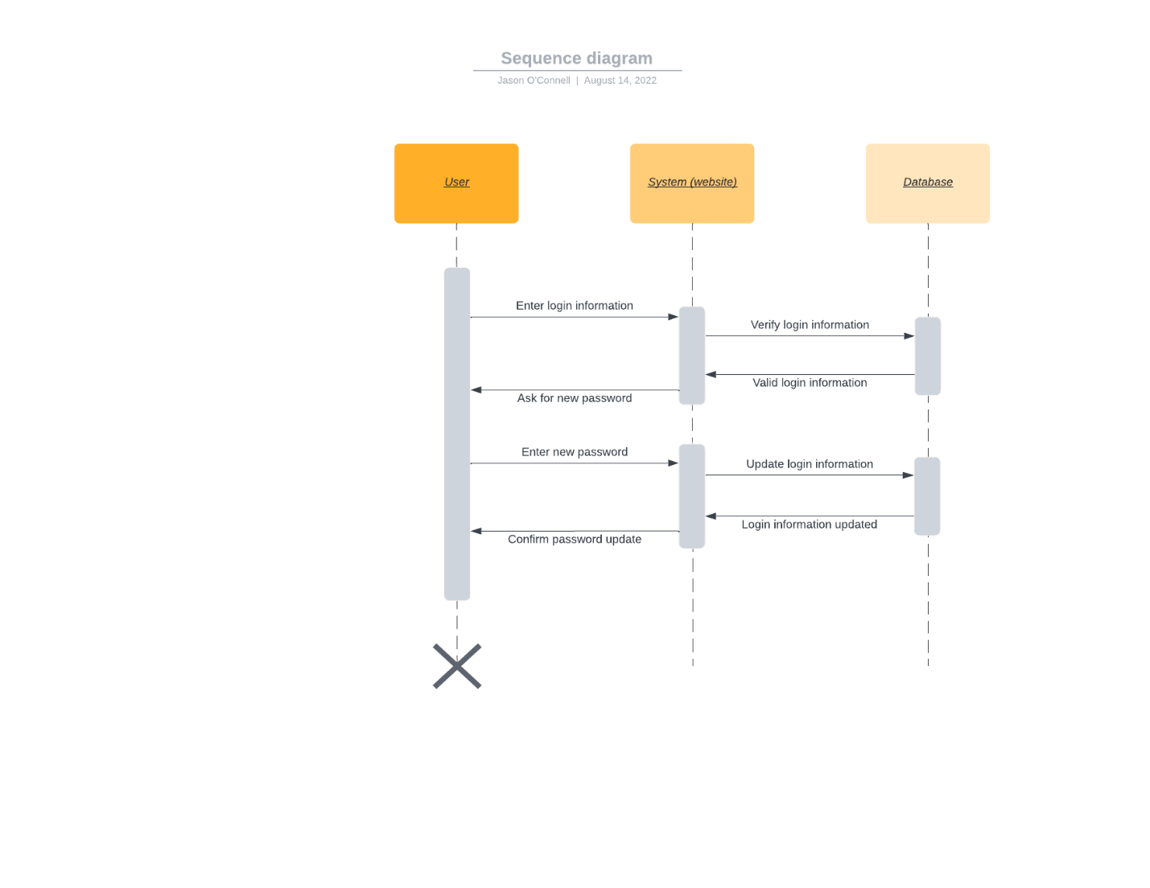

### UML Class Diagram

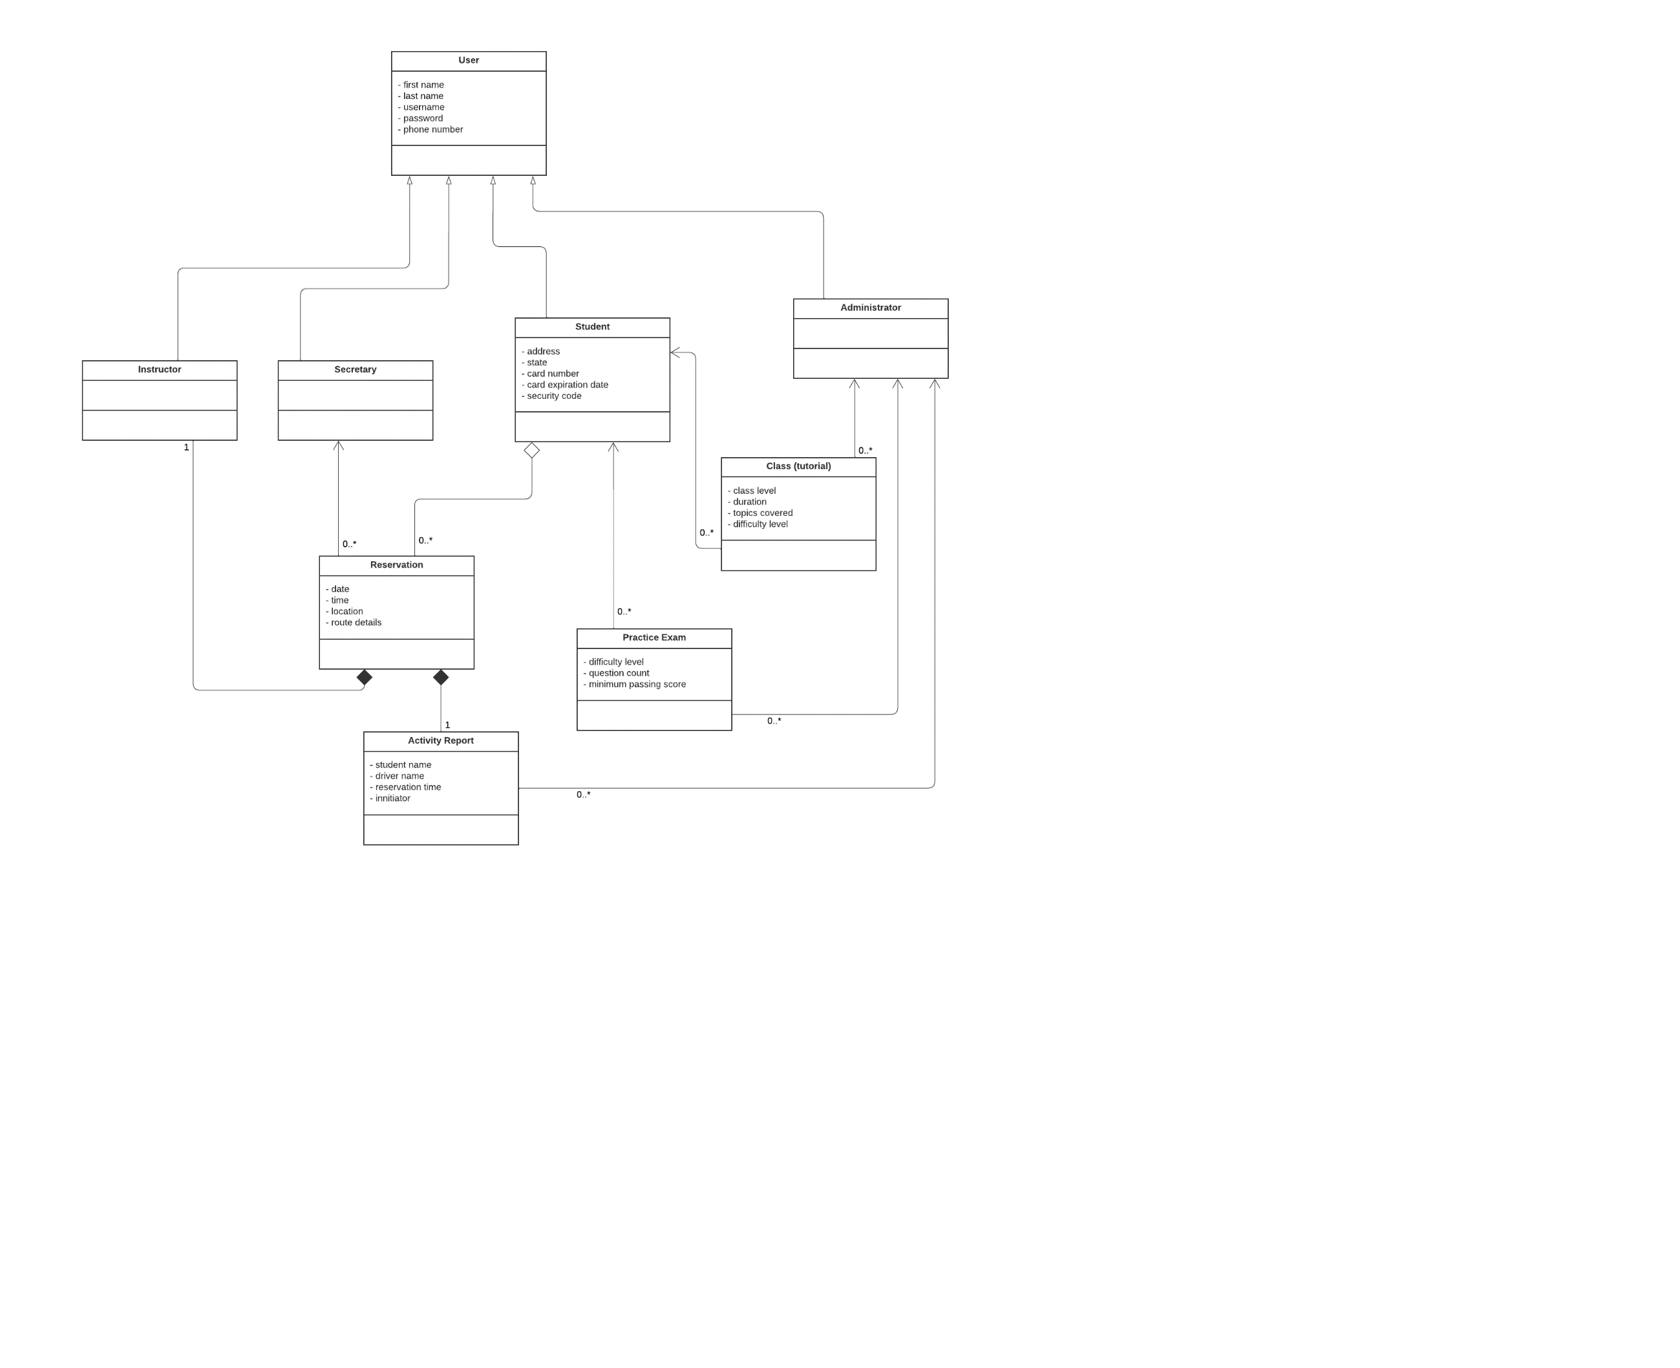

## Technical Requirements

DriverPass indicated that they wanted the system to be run via a cloud service provider (CSP) The overall form of the system is going to be in the client-server format. This means that to be able to offer the DriverPass website, the company is going to have to pay for server time through the CSP. The website requires availability for multiple types of users to be online as well. Negotiating service availability and load balancing with the CSP is going to be essential for supporting many users using the site concurrently.

DriverPass also mentioned that they want availability of this site to be cross-platform between mobile and desktop. This requires the servers to be formatted to allow connections from all of the devices in the mobile and desktop categories.

In my design document, I mentioned the need for databases. The diagrams presented illustrate the need for them. In the sequence diagram, it shows the system interacting with a database of user information. We can see from the class diagram that a user is going to have some basic information stored about them. DriverPass did not specify how many users it expects. We’ll assume somewhere around 50GB database storage will be needed to cover the user information requirements for the foreseeable future. DriverPass also indicated that students have the availability to take online courses and take practice exams. All the resources for these features need to be housed in a database. DriverPass offered little details about these features which makes it difficult to estimate the size needed. Lastly, the class diagram shows the reservation and associated activity report that is generated. A third database is going to be needed to store the reservations and activity reports. The size of such database should be in the range of the user information database size.

The Owner of DriverPass discussed in the interview that he wants to be able to print the activity logs at his leisure. This is going to require development to allow for this feature and have it be available to his user type.